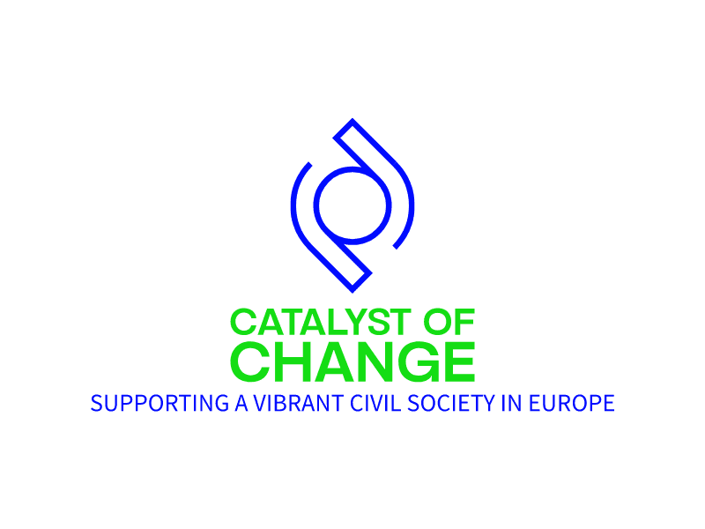

CALL FOR PROPOSALS
MONITORING, ADVOCACY AND COALITION BUILDING FOR WOMEN’S RIGHTS, ENVIRONMENTAL JUSTICE & ANTICORRUPTION GRASS ROOTS CSOS
CROATIA

APPLICATION FORM

I. General Information

Name of the organisation
Legal status of the organisation
Region(s) where the organisation operates
Address of registration and operation of the organisation
Web-site
E-mail address
Phone number
Links to the organization's social media accounts
Name of the legal rep.
Position of the legal rep.
Phone number
email address
Name of the contact person
Position of the contact person
Phone number
Email address

II. Detailed application

- Please provide a brief description of your organization, its mission and vision, its goals (Max. 100 words)

- Please describe the work of your organisation in promoting and protecting human rights and the EU fundamental values in your country (Max. 300 words).

- Please indicate the project title

- Please provide a description of the problem the project wants to address and its relevance to the current call for proposals (Max. 400 words)

- Please identify the project expected outcomes (Max. 400 words).

- Please describe the planned activities (outputs) (what, who, how, when, where) to be implemented to achieve the project’s outcome(s) and goal(s) (Max. 400 words).

- Please identify the project target group(s) (Max. 200 words)

- Please present your plan for the evaluation of the project success, including the GESI related indicators(Max. 300 words)

- What could be the main challenges or risks faced during the project implementation? How will you mitigate these risks? (Max. 250 words)

- How will this project be of an added value for the further development of your organisation? How will you incorporate the results of the project in future programming? (Max 300 words).

- What is the project duration (start and end date / number of months)?

- Please fill in the total value of the requested budget in EUR (the amount should correspond the total amount indicated in the attached budget)

- Please feel free to include any materials, links, or supporting information in support of your application.

III. References
Please provide in the fields below the relevant projects in the field of promotion and protection of human rights within the project’s target countries in which your organization has been involved. Include the following information: project title, very short description, administering organization and implementation period. (Max. 3 projects).
Project 1
Project 2
Project 3

IV. Applicant’s Declaration

☐ By checking this box, I declare that:
- The information provided in the application is true and accurate.

- The information provided in the application can be shared with the selection committee of the Netherlands Helsinki Committee within the framework of the Call for Proposals: Monitoring, advocacy and coalition building for women’s rights, environmental & anticorruption grass roots CSOs from Bulgaria, Croatia, Romania, Slovenia, and Portugal

- I consent to the processing and storage of personal and other data specified in the answers to the questions of this application.

- I accept the terms and conditions of the call for proposals and the requirements of the competition.

- I accept that the application will adhere to the EU values (as required by the EU).

- I guarantee that there is no funding for the proposed idea submitted in the application from any other donor and no pending project funding (i.e., the project proposal has been submitted and is awaiting approval from another donor).

- I am ready to provide additional information for the purpose of evaluating my application.

2222222222
Date of submission:

2222222222

Signature:

