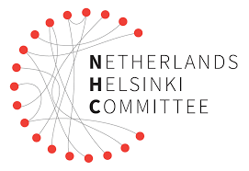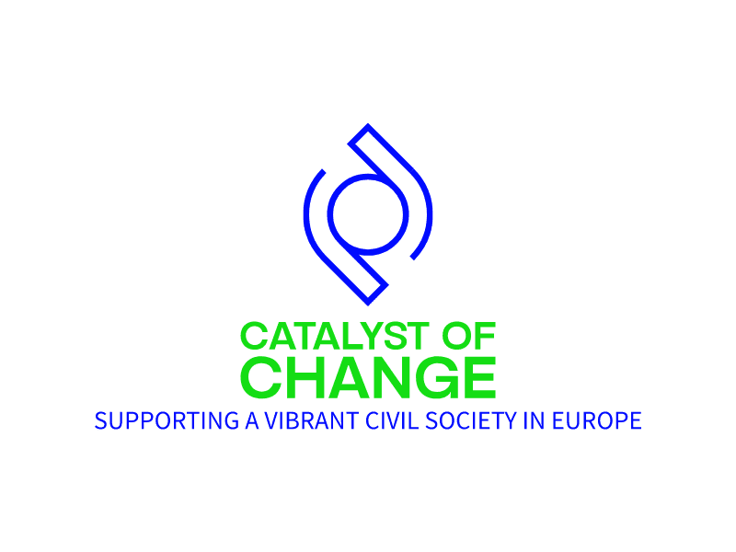

# CALL FOR PROPOSALS

MONITORING, ADVOCACY AND COALITION BUILDING FOR WOMEN’S RIGHTS, ENVIRONMENTAL JUSTICE & ANTICORRUPTION GRASS ROOTS CSOS

# PORTUGAL

# Background

# Against the background of concerning shrinking civic space trends in the European Union (EU), this project aims to contribute to creating an enabling environment for civil society in five EU Member States that are in acute need of civil society strengthening: Romania, Bulgaria, Croatia, Slovenia, and Portugal. The project will allow Civil Society Organisations (CSO’s) working on women’s rights, environmental justice, and anti-corruption to be more effective in the promotion of EU values, be more resilient to threats, and be able to quickly respond to concerning trends affecting space for civil society in their respective countries. This will ultimately lead to better protection, promotion, and acknowledgment of the EU fundamental rights and values in the target countries and, consequently, will contribute to strengthening respect for the EU values at the EU level too. To address these concerning developments, the project will contribute to:

# Enhancing civil society’s response to new trends affecting democratic and civic space and civil society;

# Strengthening effectiveness, accountability and sustainability of grassroots CSOs;

# Enhancing visibility and understanding of the work of grassroots CSOs supported by the project.

# Objective of the Call

The general objective of the call is to enhance civil society’s response to new trends affecting democratic and civic space and civil society in the target countries. This call will ultimately help contributing to increase collaboration and networking among CSOs working in the areas of women's rights, anti-corruption, and environmental justice. It will also encourage CSOs to come together, share resources, exchange knowledge and experiences, and build stronger coalitions at the local, regional, and national levels. Furthermore, it will empower CSOs to implement outreach initiatives aimed at raising awareness about the issues they address, such as workshops, seminars, and media campaigns to engage communities, decision-makers, and the general public in discussions and actions related to women's rights, anti-corruption measures, and environmental justice.

# Grant amount and duration

The NHC aims to provide approximately **10 grants**, each grant between **10,000 and 15,000 EUR.** The project will have a **maximum duration of 12 months.**

The anticipated starting date for the selected projects is **2nd of May 2024.**

# Eligibility Criteria

The grant can be received by:

* **Registered civil society organisations**[1] working on the protection and promotion of EU values including on enhancing women’s rights, and/or environmental justice and/ or anti-corruption.
* **CSO’s upholding and respecting EU values** in their work (such as respect for human dignity, freedom, democracy, equality, the rule of law and human rights, including the rights of minorities).

**Exclusion criteria:**

* CSO’s breaching EU values or with a political/religious affiliation as well as public administration institutions, state agencies, local or regional authorities, are not eligible for this call.

# Eligible types of activities

* Data collection on rights violations;
* Publication of monitoring reports;
* Development of monitoring methodology;
* Developing an advocacy strategy;
* Advocacy and lobby campaigns;
* Stakeholder meetings;
* Organising regional coordination meetings;
* Participation in coalition building activities.

# Eligible Costs

The development of a realistic budget is crucial for a successful implementation of the project’s activities. The costs **may include (but are not limited to):**

# Personnel Expenses;

# Travel and Accommodation;

# Communication and Outreach;

# Research and Data collection;

# Training and Capacity Building;

# Advocacy and Lobbying;

# Technology and Equipment;

# Venue Rental;

# Translation and Interpretation;

# Administrative expenses/office supplies;

# Costs associated with monitoring project progress and evaluating the impact of project activities.

# Ineligible Costs

The budget must be in line with the activities described in the application form. The following activities and expenditures **are not eligible under this call:**

* Personal Expenses (any expenses of a personal nature, such as personal phone bills, personal shopping, or personal travel not directly related to the project);
* Retrospective activities (costs related to activities implemented prior to signing the grant agreement);
* Humanitarian support to third parties;
* Medical or any other unexpected (emergency) expenses;
* Commercial activities;
* Infrastructure projects (constructing roads, bridges, buildings, etc.);
* Capital Expenditures (expenses for purchasing fixed assets, such as buildings or land);
* Political or religious activities;
* Purchase of Non-Essential Items (costs or items not directly essential for project implementation);
* Environmentally harmful projects;

# Application Process

Interested organisations are encouraged to [**APPLY ONLINE**](https://app.smartsheet.com/b/form/9558e6549f324653ad4206795a84d88f) in **Portuguese and English** or in their respective language no later than **14th of April 2024.**

The following documents need to be attached:

* **Complete application form** (answering all the questions);
* **Filled out budget form** (download the template);
* **Registration certificate** of the organisation or a proof of registration from earlier years;
* **Statute of the organisation**.

For questions regarding the call for proposals or the application procedure, please send us an email to [hrd@nhc.nl](mailto:hrd@nhc.nl) <mailto:> **no later than 25th of March 2024.**

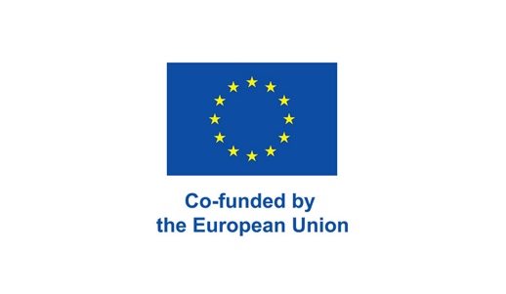**Only full applications** consisting of a completed online application form and all requested additional documents **will be assessed**.

# Selection Process

An independent evaluation committee will evaluate submitted proposals consisting of three experts with voting power, a chairperson and a secretary. The group of experts will be composed of experts affiliated to NHC and/or NHC partners in the countries. **The evaluation will be based on the following criteria:**

|  |  |  |
| --- | --- | --- |
|  | **Criteria** | **Maximum score** |
| **1** | How relevant is the proposal to the objectives and priorities of the call for proposals? | 20 |
| **2** | How relevant is the proposal to the particular needs and constraints of the target groups? | 20 |
| **3** | How coherent is the design of the action? Does the proposal indicate the expected results to be achieved by the action? Does the intervention logic explain the rationale to achieve the expected results? Are the activities proposed appropriate, practical, and consistent with the envisaged outcome(s)? | 15 |
| **4** | Is the action plan for implementing the action clear and feasible? Is the timeline realistic? | 10 |
| **5** | Does the proposal include an effective and efficient monitoring system? | 10 |
| **6** | Realistic and feasible budget (Are the activities appropriately reflected in the budget?) | 10 |
| **7** | Analysis of risks and mitigation measures | 5 |
| **8** | Sustainability of activities after the end of the project | 10 |
| **Total:** | | **100** |

The threshold score for receiving sub-grants is 70 points.

The applicants will receive feedback on their proposals via email within 4 weeks after the submission deadline.

# The outcomes of the call will be published on the [project’s website](https://www.nhc.nl/catalyst-of-change-supporting-a-vibrant-civil-society-in-europe/) and will include a description of the selected projects, award dates, project durations as well as the names and countries of the grantees.

Any concerns or feedback related to the proposal selection process can be submitted to the NHC via e-mail to [hrd@nhc.nl](mailto:hrd@nhc.nl)



1. Registered CSO "refers to an organization that is a legal entity, operates on a non-profit basis, and has been established in one of the project's target countries.